University/Academic Institution: Sandip University Course Name: M.Tech ACDS

Batch Name: 2017-19 Module Name: Advanced Data Structures

Pre -Assignment:

1. Write a program in c++ using increment(Post and Pre) and decrement operators

ANS:

CODE:

#include<iostream>

using namespace std;

int main()

{

// For Increment:

int a=9,c;

c=a++;

cout<<"the value of c is:"<<c<<endl;

cout<<"the value of a is:"<<a<<endl;

c=++a;

cout<<"the value of c now is:"<<c<<endl;

// For Decrement:

c=a--;

cout<<"the value of c is:"<<c<<endl;

cout<<"the value of a is:"<<a<<endl;

c=--a;

cout<<"the value of c is:"<<c<<endl;

return 0;

}

OUTPUT:

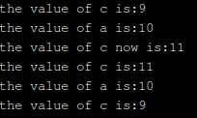

1. Write a program in c++ using all flow control statements (if,

else, for ,while and switch)

ANS:

CODE:

#include<iostream>

using namespace std;

int main()

{

int a=25,b=5,c,d,e;

//for if else:

if (a==25)

{

c=a+b;

}

else

{

c=b-a;

}

cout<<"the output is:"<<c<<endl;

// For function:

for(d=0;d<=b;d++)

{

if(d==1)

{

continue;

}

cout<<"hey dude"<<"\n"<<endl;

}

// While loop:

int j=5;

while(j>0)

{

cout<<"whats up"<<"\n"<<endl;

j--;

}

// Switch case:

{

char o;

float num1, num2;

cout << "Enter an operator (+, -, \*, /): ";

cin >> o;

cout << "Enter two operands: ";

cin >> num1 >> num2;

switch (o)

{

case '+':

cout << num1 << " + " << num2 << " = " << num1+num2;

break;

case '-':

cout << num1 << " - " << num2 << " = " << num1-num2;

break;

case '\*':

cout << num1 << " \* " << num2 << " = " << num1\*num2;

break;

case '/':

cout << num1 << " / " << num2 << " = " << num1/num2;

break;

default:

// operator is doesn't match any case constant (+, -, \*, /)

cout << "Error! operator is not correct";

break;

}

}

return 0;

}

OUTPUT:

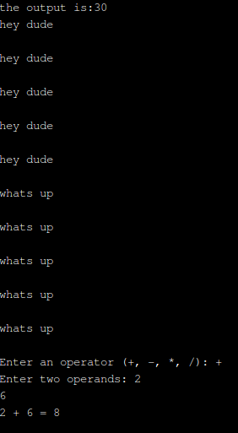

3. Write a program using functions which accept two integers as an argument and return its sum, sub, divide and multiply. Call all the functions from main( )

ANS:

CODE:

#include<iostream>

#include<conio.h>

using namespace std;

int add(int ,int );

int sub(int ,int );

int di(int ,int );

int mul(int ,int );

int main()

{

clrscr();

int a,b;

cout<<"Enter a and b" ;

cin>>a>>b;

cout<<"\n Addition is::\n" ;

cout<<add(a,b);

cout<<"\n";

cout<<"\n Subtraction is ::\n";

cout<<sub(a,b);

cout<<"\n";

cout<<"\n division is ::\n";

cout<<di(a,b);

cout<<"\n";

cout<<"\n Multiplication is ::\n";

cout<<mul(a,b);

cout<<"\n";

getch();

return 0;

}

int add(int a,int b)

{

return(a+b);

}

int sub(int a,int b)

{

return(a-b);

}

int di(int a,int b)

{

return(a/b);

}

int mul(int a,int b)

{

return(a\*b);

}

OUTPUT:

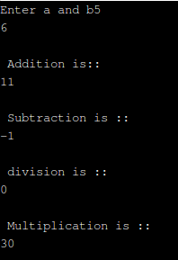

4. Write a program which input value of good, rate(18%) from user and calculate Goods and Service Tax.

ANS:

CODE:

#include<iostream>

#include<conio.h>

using namespace std;

int main()

{

float amt,GST,rate;

cout<<"Enter amount of goods \n";

cin>>amt;

cout<<"\n The amount is ::"<<amt;

cout<<"\n Enter rate \n";

cin>>rate;

cout<<"\n The rate is ::"<<rate;

GST=(amt\*rate)/100;

cout<<"\n The goods and service tax is ::"<<GST;

getch();

return 0;

}

OUTPUT:

